**Operating Systems – Lab 06**

**Name:** Hafsa Salman

**Roll no.** 22K-5161

Experiment 6A

**Task no. 01**

Compile and execute the above code. Open a separate terminal window to note the process ids using in this code.

Code:

//Hafsa Salman

//22K-5161

//Experiment 6A: Task no. 01

#include<stdio.h>

#include<string.h>

#include<unistd.h>

#include<sys/types.h>

#define BUFFER_SIZE 25

#define READ_END 0

#define WRITE_END 1

int main(void)

{

char write_msg[BUFFER_SIZE] = "Greetings";

char read_msg[BUFFER_SIZE];

int fd[2];

pid_t pid;

if (pipe(fd) == -1)

{

fprintf(stderr, "Pipe Failed!\n");

return 1;

}

pid = fork();

if (pid < 0)

{

fprintf(stderr, "Fork Failed!\n");

return 1;

}

if (pid > 0)

{

close(fd[READ_END]);

write(fd[WRITE_END], write_msg, strlen(write_msg)+1);

close(fd[WRITE_END]);

}

else

{

close(fd[WRITE_END]);

read(fd[READ_END], read_msg, BUFFER_SIZE);

printf("Read %s\n", read_msg);

close(fd[READ_END]);

}

return 0;

}

Output:

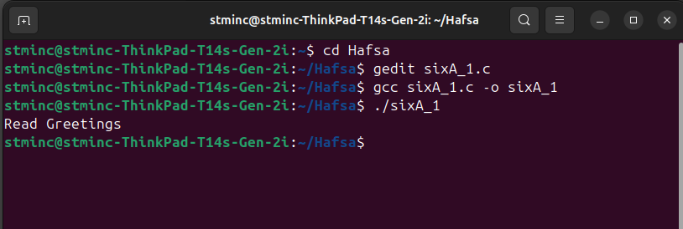

**Task no. 02**

Modify the code such that it tasks write_msg value from user terminal.

Code:

//Hafsa Salman

//22K-5161

//Experiment 6A: Task no. 02

#include<stdio.h>

#include<string.h>

#include<unistd.h>

#include<sys/types.h>

#define BUFFER_SIZE 25

#define READ_END 0

#define WRITE_END 1

int main(void)

{

char write_msg[BUFFER_SIZE];

char read_msg[BUFFER_SIZE];

int fd[2];

printf("Enter message: ");

fgets(write_msg, BUFFER_SIZE, stdin);

pid_t pid;

if (pipe(fd) == -1)

{

fprintf(stderr, "Pipe Failed!\n");

return 1;

}

pid = fork();

if (pid < 0)

{

fprintf(stderr, "Fork Failed!\n");

return 1;

}

if (pid > 0)

{

close(fd[READ_END]);

write(fd[WRITE_END], write_msg, strlen(write_msg)+1);

close(fd[WRITE_END]);

}

else

{

close(fd[WRITE_END]);

read(fd[READ_END], read_msg, BUFFER_SIZE);

printf("Read %s\n", read_msg);

close(fd[READ_END]);

}

return 0;

}

Output:

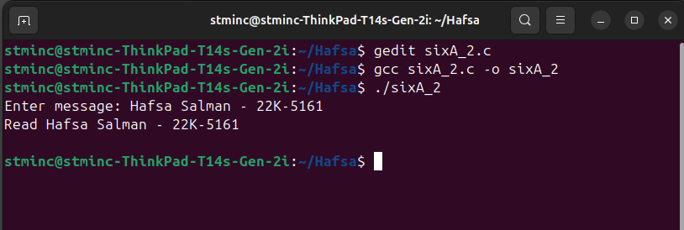

Experiment 6B

**Task no. 01**

Compile and execute the producer code above that uses named pipe. Correct errors, if any.

Code:

//Hafsa Salman

//22K-5161

//Experminent 6B: Task no. 01

#include<stdio.h>

#include<stdlib.h>

#include<unistd.h>

#include<fcntl.h>

#include<sys/types.h>

#include<sys/stat.h>

#include<string.h>

#define FIFO_FILE "/tmp/myfifo"

int main()

{

int fd;

char buffer[BUFSIZ];

ssize_t num_bytes;

mkfifo(FIFO_FILE, 0666);

fd = open(FIFO_FILE, O_WRONLY);

if (fd == -1)

{

perror("open");

exit(EXIT_FAILURE);

}

while (1)

{

printf("Producer: Enter a message (or 'exit' to quit): ");

fgets(buffer, BUFSIZ, stdin);

num_bytes = write(fd, buffer, strlen(buffer));

if (num_bytes == -1)

{

perror("write");

exit(EXIT_FAILURE);

}

if (strncmp(buffer, "exit", 4) == 0)

{

break;

}

}

close(fd);

unlink(FIFO_FILE);

return 0;

}

Output:

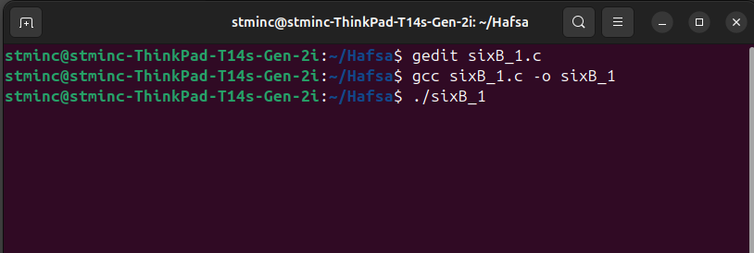

//Other screenshots under Task no. 03 (Consumer code)

**Task no. 02**

Carefully study the producer code and verify that the FIFO_FILE has been created.

Output:

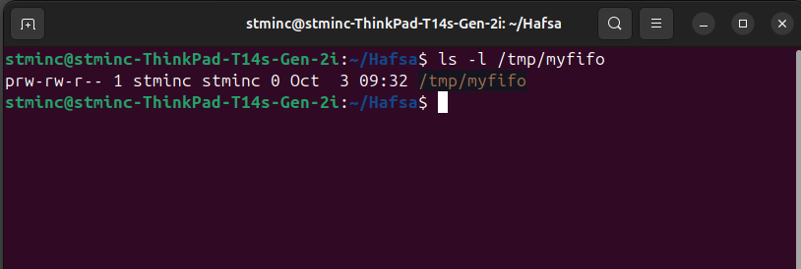

**Task no. 03**

Now, write consumer code for the above producer using the following hints:

• Open FIFO_FILE in read only mode using O_RDONLY

• Consumer read the data using num_bytes = read(fd, buffer, BUFSIZ);

• Display the data sent by the producer using

printf("Consumer: Received message: %s", buffer);

Code:

//Hafsa Salman

//22K-5161

//Experiment 6B: Task no. 03

#include <stdio.h>

#include <stdlib.h>

#include <unistd.h>

#include <fcntl.h>

#include <sys/types.h>

#include <sys/stat.h>

#include<string.h>

#define FIFO_FILE "/tmp/myfifo"

int main()

{

int fd;

char buffer[BUFSIZ];

ssize_t num_bytes;

fd = open(FIFO_FILE, O_RDONLY);

if (fd == -1)

{

perror("open");

exit(EXIT_FAILURE);

}

while (1)

{

num_bytes = read(fd, buffer, BUFSIZ);

if (num_bytes == -1)

{

perror("read");

break;

}

else if (num_bytes == 0)

{

printf("Producer exited the FIFO. Exiting...\n");

break;

}

else

{

buffer[num_bytes] = '\0';

printf("Consumer - Message recieved: %s", buffer);

if (strncmp(buffer, "exit", 4) == 0)

{

printf("Exit");

break;

}

}

}

close(fd);

return 0;

}

Output:

Producer terminal:

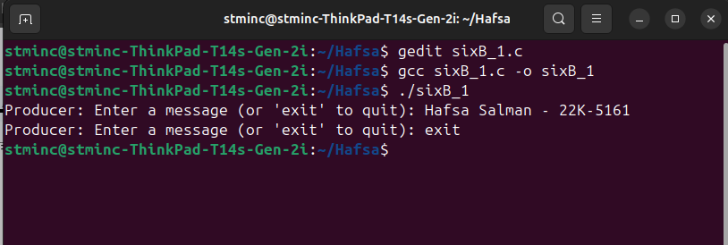

Consumer Terminal:

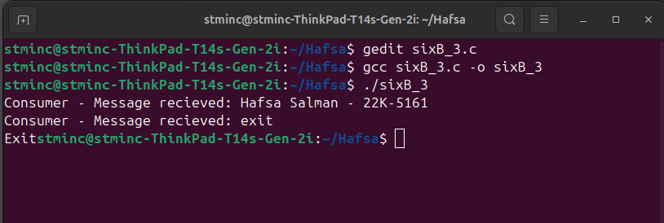

Experiment 6C

**Task no. 01**

Compile and execute producer code.

Code:

//Hafsa Salman

//22K-5161

//Experiment 6C: Task no. 01

#include<stdio.h>

#include<stdlib.h>

#include<string.h>

#include<fcntl.h>

#include<sys/shm.h>

#include<sys/stat.h>

#include<sys/mman.h>

#include<unistd.h>

int main()

{

const int SIZE = 4096;

const char *name = "OS";

const char *message_0 = "Hello";

const char *message_1 = "World!";

int fd;

char *ptr;

fd = shm_open(name, O_CREAT | O_RDWR, 0666);

ftruncate(fd, SIZE);

ptr = (char *)mmap(0, SIZE, PROT_READ | PROT_WRITE, MAP_SHARED, fd, 0);

sprintf(ptr, "%s", message_0);

ptr += strlen(message_0);

sprintf(ptr, "%s", message_1);

ptr += strlen(message_1);

return 0;

}

Output:

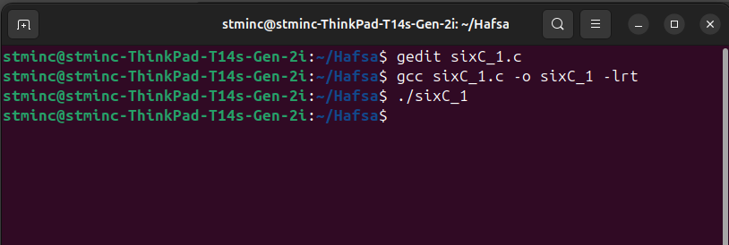

**Task no. 02**

Compile and execute the consumer code. It will give a run-time error. Why?

Code:

//Hafsa Salman

//22K-5161

//Experiment 6C: Task no. 02

#include<stdio.h>

#include<stdlib.h>

#include<fcntl.h>

#include<sys/shm.h>

#include<sys/stat.h>

#include<sys/mman.h>

int main()

{

const int SIZE = 4096;

const char *name = "OS";

int fd;

char *ptr;

fd = shm_open(name, O_RDONLY, 0666);

ptr = (char *)mmap(0, SIZE, PROT_READ | PROT_WRITE, MAP_SHARED, fd, 0);

printf("%s", (char *)ptr);

shm_unlink(name);

return 0;

}

Output:

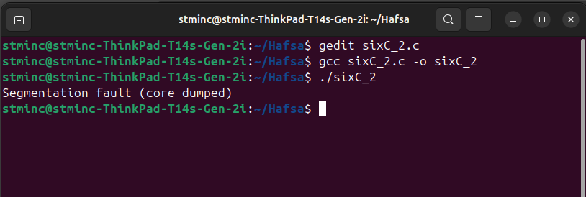

Reason:

It is mapping file writable without having write permission on the file descriptor.

**Task no. 03**

Now modify the producer code such that the producer and the consumer code run concurrently as two processes. Now the consumer code will print the message.

Code:

//Hafsa Salman

//22K-5161

//Experiment 6C: Task no. 03

#include<stdio.h>

#include<stdlib.h>

#include<string.h>

#include<fcntl.h>

#include<sys/shm.h>

#include<sys/stat.h>

#include<sys/mman.h>

#include<unistd.h>

int main()

{

const int SIZE = 4096;

const char *name = "OS";

const char *message_0 = "Hello";

const char *message_1 = "World!";

int fd;

char *ptr;

fd = shm_open(name, O_CREAT | O_RDWR, 0666);

if (fd == -1)

{

perror("shm_error");

exit(1);

}

ftruncate(fd, SIZE);

ptr = (char *)mmap(0, SIZE, PROT_READ | PROT_WRITE, MAP_SHARED, fd, 0);

if (ptr == MAP_FAILED)

{

perror("mmap");

exit(1);

}

sprintf(ptr, "%s", message_0);

ptr += strlen(message_0);

sprintf(ptr, "%s", message_1);

ptr += strlen(message_1);

return 0;

}

Output:

Producer Terminal:

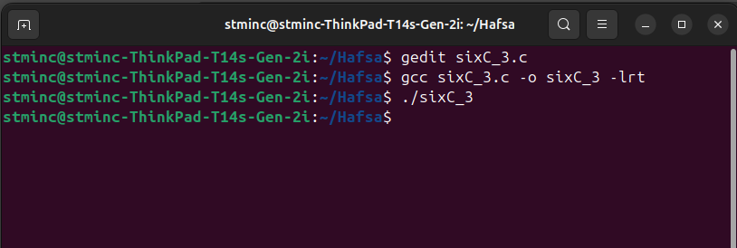

Consumer Terminal:

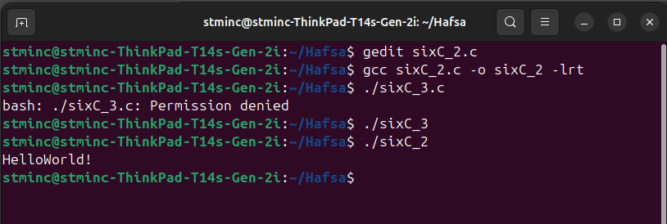

**Task no. 04:**

Now modify the consumer code to print the second message.

Code:

//Hafsa Salman

//22K-5161

//Experiment 6C: Task no. 04

#include<stdio.h>

#include<stdlib.h>

#include<fcntl.h>

#include<sys/shm.h>

#include<sys/stat.h>

#include<sys/mman.h>

#include<unistd.h>

int main()

{

const int SIZE = 4096;

const char *name = "OS";

int fd;

char *ptr;

fd = shm_open(name, O_RDONLY, 0666);

ptr = (char *)mmap(0, SIZE, PROT_READ, MAP_SHARED, fd, 0);

printf("%s \n", (char *)ptr);

shm_unlink(name);

return 0;

}

Output:

